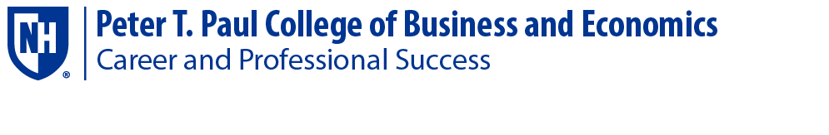

Student Services Fall 2020:

Here is how to make appointments, attend walk in’s, sign up for employer events!

One on One Career Counseling Appointments: Visit Handshake and make an appointment.
https://unh.joinhandshake.com

Career Counselors by Major: Anyone in Paul CaPS can meet with you but if you want to meet within your option here are your options!

Megan Turnbull: Accounting/Finance/Economics Majors
Leslie Smith: Marketing/ISBA/Entrepreneurship/Master Level students
Katherine Maloney: Hospitality/Management

Walk in/Zoom in Days, times and Links:

Monday’s 1pm-3pm- G35 for in person Walk in’s
Tuesday’s 1pm-3pm- Zoom in: https://unhcaps.info/dropinspaulcola
Wednesday’s 1pm-3pm- Zoom in: https://unhcaps.info/dropinspaulcola

Canvas Career Pages:
Career information pages by major!
We will share information on events, resources for your area of interest such as specific resume templates.
Videos on how to navigate Handshake and prepare for career events.

Please contact Kimberly.Clark@unh.edu if you would like to be added to a page.

Events: All employer events are virtual. You must set up an account on Handshake and register for events!

For Accounting majors check the Accounting Student Association page on Canvas for events in your major!

UNH CaPS Part Time Work Study Fair: Thursday September 3rd 12pm-2pm
Resume Review Day: September 22nd, 12pm-3pm
Finance Fair: Friday September 25th: 11am-1pm
UNH Career Fair: Wednesday October 7th: 3pm-7pm

